AutoSAP SBP Hourly Monitoring
Solution Manager signatures signify that approvers have read, understood, and agrees with the content of this document.
Name | Job Title and Role
Erry Lavakumar | The author is signing to confirm that this document has been prepared in accordance with an approved document management process, that content is consistent with the deliverable definition found in Specify System, that relevant input from any contributory authors has been included and that an appropriate review / editing process has been conducted.
Erry Lavakumar  Nikhil Chalikwar  Akoju Sharanya | The Developer (selected by the Project Manager as responsible for the design of the system) is signing to confirm that the Design Specification is fit for purpose, that it will deliver a computer system that satisfies the System Requirements and that it will be used for the development or configuration of the computer system

Table of Contents
1 Introduction 3
2 Definition/Acronyms 3
3 General Statement of Design 3
3.1 Assumptions 3
4 References 3
5 Platform Architecture and Environment 3
6 Software Architecture 4
6.1 Generic Solution Details 5
7 System Operation Specification 8
8 Data 8
9 Security 8
10 Revision History 8
11 Appendices 8
11 Appendix-Program Logic 9

Introduction
The system will log in to the SBP system to monitor the T-Codes DB01, DB02, SE38, SM37, SM51, SM58, SM59, SMLG, ST06, ST07, ST22. It will send a monitoring report every hour. This document describes the automation process of hourly SBP system monitoring.

Definition/Acronyms
Item | Definition
API | Application Programme Interface
SAP | Systems Applications and Products

General Statement of Design
Design methodology/principles | This task is developed to overcome the manual effort and time spent on routine activity. The scripts are developed for end-end execution of Automation process of SBP hourly Monitoring.  Automation script will login to SBP system of SAP to check the T-codes DB01, DB02, SE38, SM37, SM51, SM58, SM59, SMLG, ST06, ST07, ST22 and sends monitoring mail for every 1hr along with the evidence.
Tools + version | Python 3.6, Pandas, SAP GUI 760, wincom32 API, SMTP Mail.
Programming standards | GSK Programming Standards.

Assumptions
Assuming the T-codes DB01, DB02, SE38, SM37, SM51, SM58, SM59, SMLG, ST06, ST07, ST22 are working fine.

References
None

Platform Architecture and Environment
Python 3.6

Software Architecture
Element ID | Developed Software Unit name | ID | Programming Language(s) | Description of Purpose
DS/Basis_SBP-Hourlymonitoring/0001 | Program | autosapVxMon.py | Python | This is the main file which imports all the required neighboring python files and arrange them in a sequence to perform required action.
DS/Basis_SBP-Hourlymonitoring/0002 | Program | cc.py | Python | This file reads the credentials to login to the SAP system
DS/Basis_SBP-Hourlymonitoring/0003 | Program | logon.py | Python | This file will login into SAP System through SAP GUI Logon Pad.
DS/Basis_SBP-Hourlymonitoring/0004 | Program | (Respective T-code).py | Python | Performs respective T-code actions and extract/capture the evidence.
DS/Basis_SBP-Hourlymonitoring/0005 | Program | xlreport.py | Python | Generates a report with respective values and status from the evidence.
DS/Basis_SBP-Hourlymonitoring/0006 | Program | sender.py | Python | Sends mail to the required recipients with summary report in mail body and all the evidence in attachments.

Generic Solution Details
Authorisations
No Authorisations checks implemented as Authorisations are derived from user.
Message Class and Messages:
NA
Manual Process:
SYSTEM: SBP
Login into SBP system.
Step1: Enter the T-Code /ndb01 execute and take the screenshot.
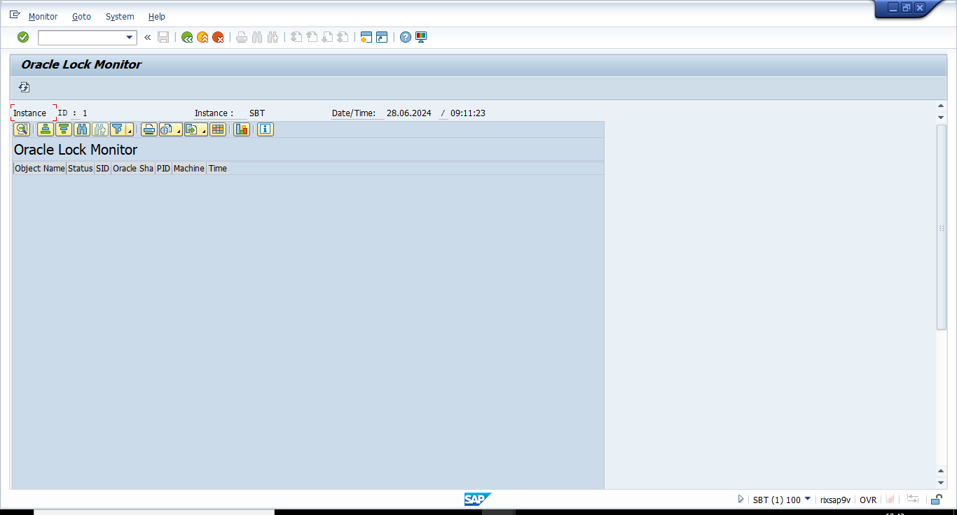

Step2: Enter T-code : /nDB02 and go to Space > Tablespaces > Overview to get the Table Space Names and its respective Used %.
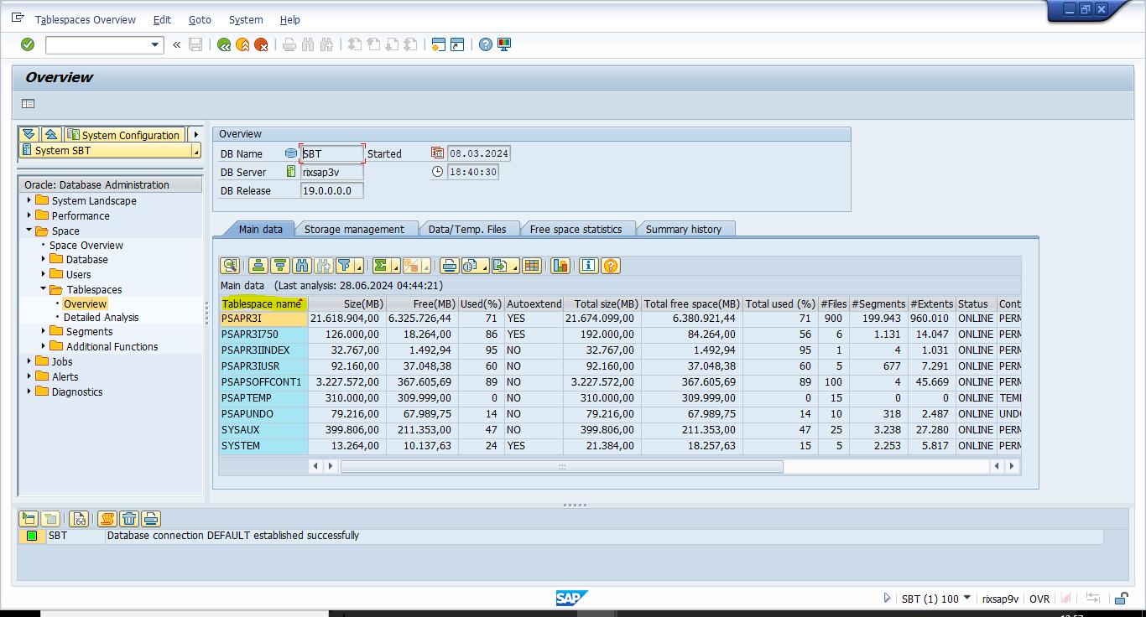
Step3:
- Enter the transaction /nSE38 and give – Program: ‘/SDF/MON’ and select ‘Variants’ and click on Display.
- Then give the Variant as ‘Test’(any name) and click on Create.
- Then select –‘For All Selection Screens’ on the pop up then continue

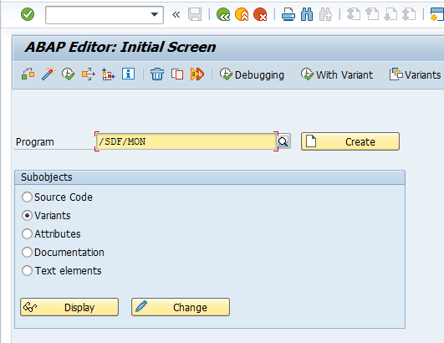 | 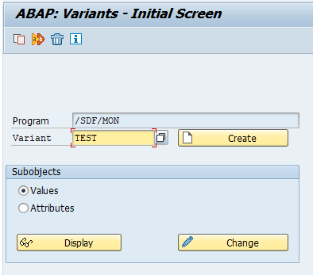 | 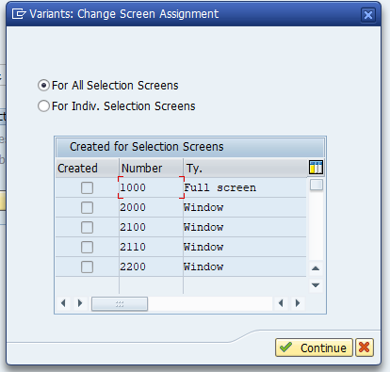

- Click on ‘Schedule New Monitoring’ and ‘Show Analysis’ In respective screens to get the below report:
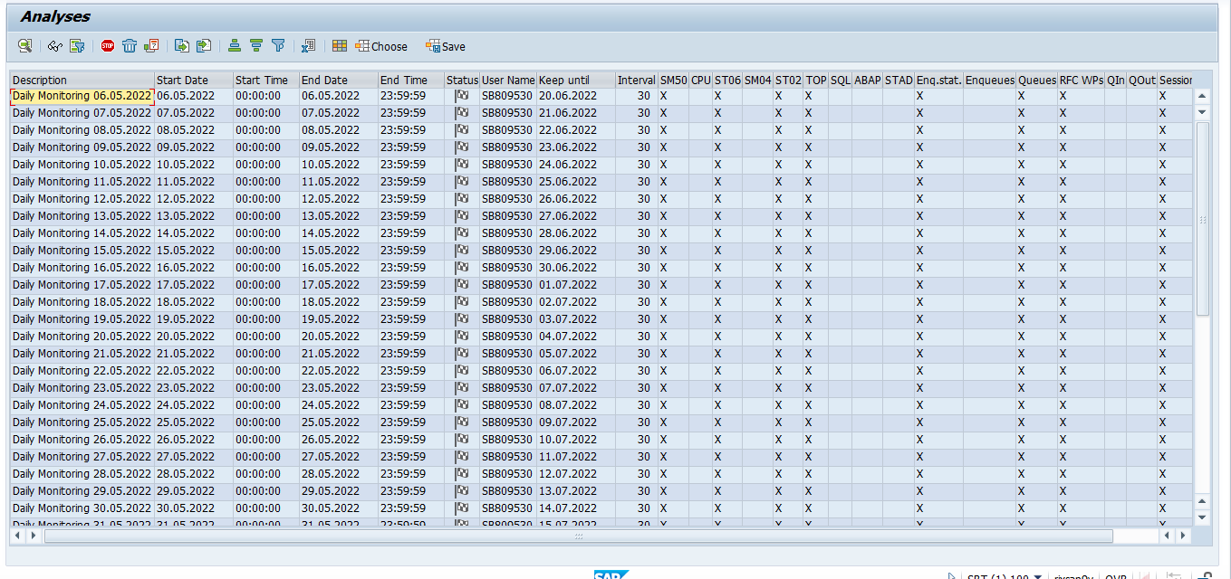
- Analyse and find the Logins and sessions,Extended memory, heap memory and WPs from the above report.

Step4: Enter the T-code /nSM37 and check if any job is running more than one day:
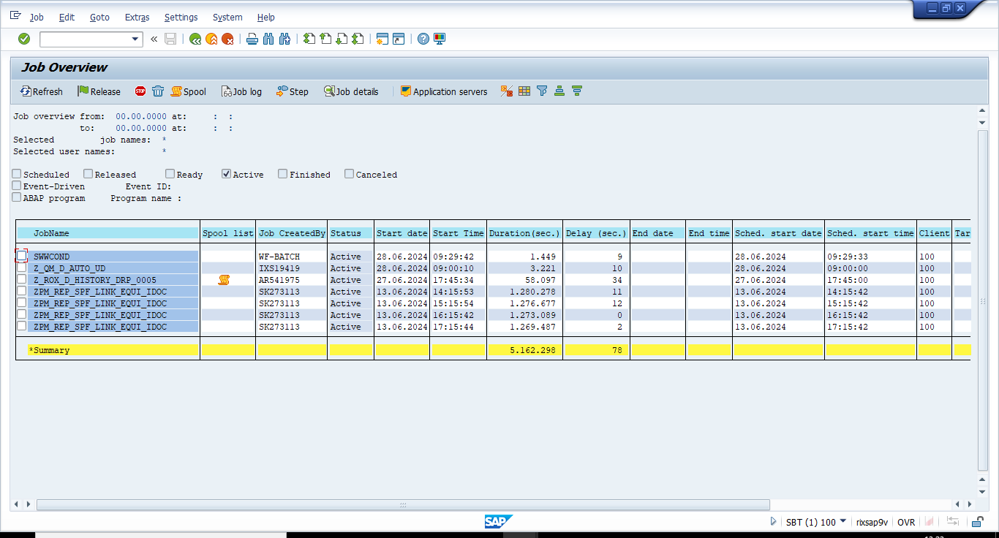

Step5: Enter the transaction /nSM51 and take the screenshot.
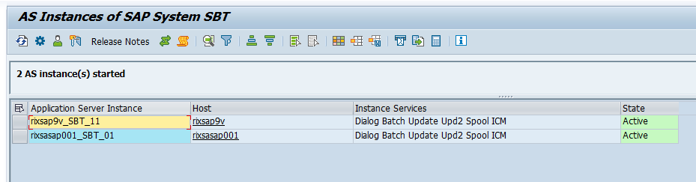
Step6: Enter the transaction /nSM58 and check Transaction RFCs for Current Day with Username as ‘*’.
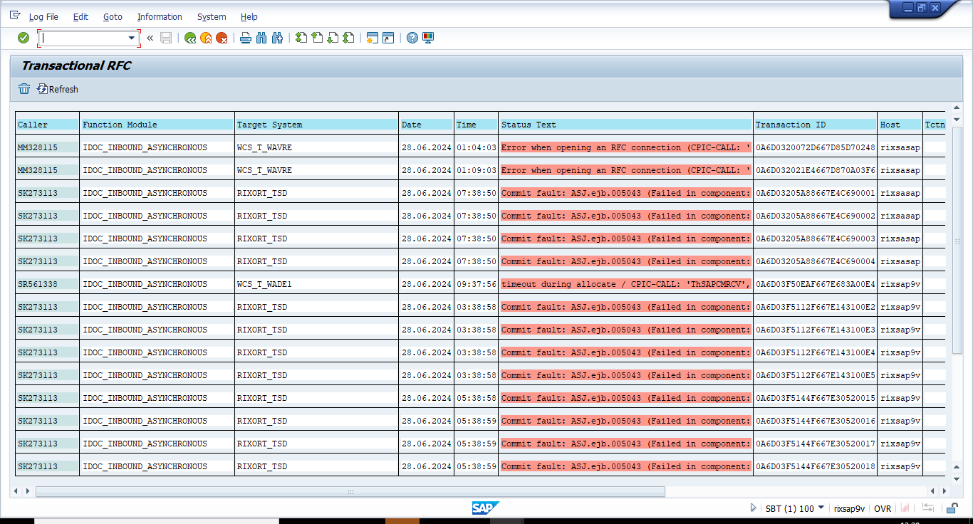

Step7: Enter the transaction /nSM59 and go to TCP/IP Connections and check if the below Seal Servers are active or not: 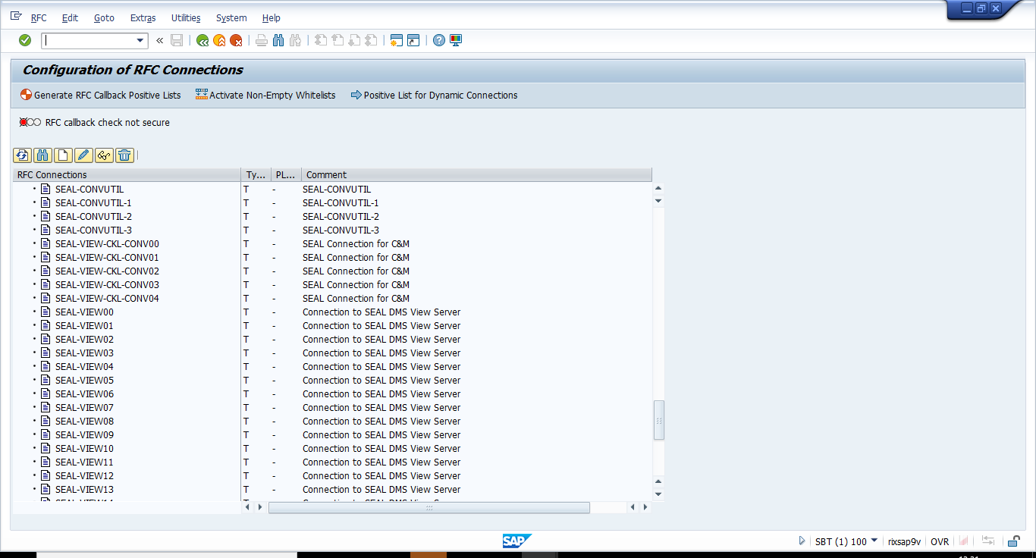

Step8: Enter /nSMLG transaction and take the screenshot:
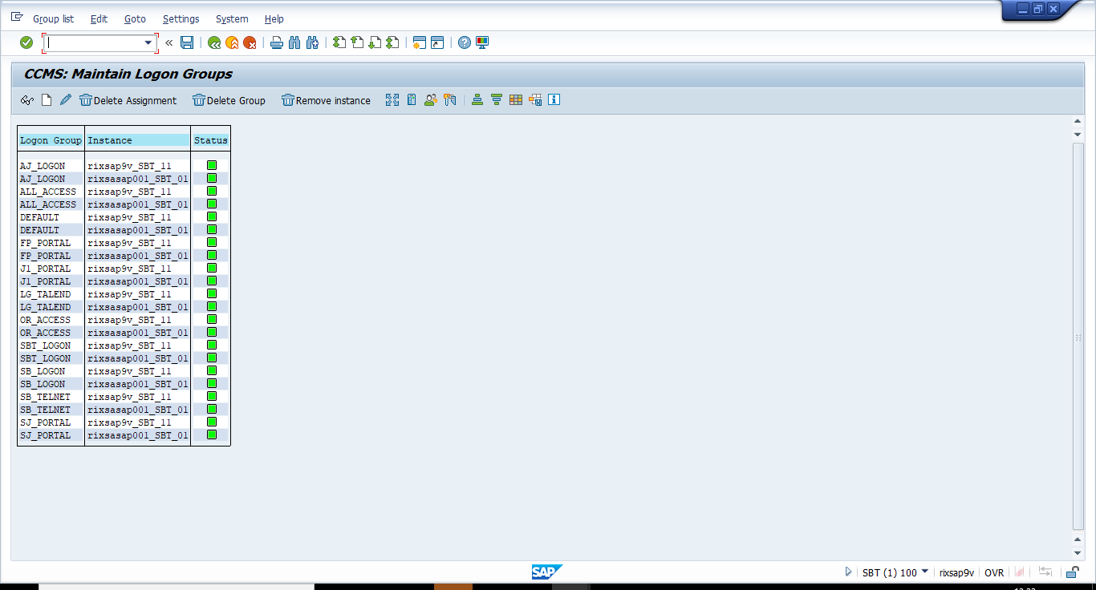

Step9: Enter the /nST06 T-code and click on ‘SBP’ System name and download the report to analyse the CPU% , Free Memory, RAgent and “oracle/SBP/oraarch” Disk CPU:
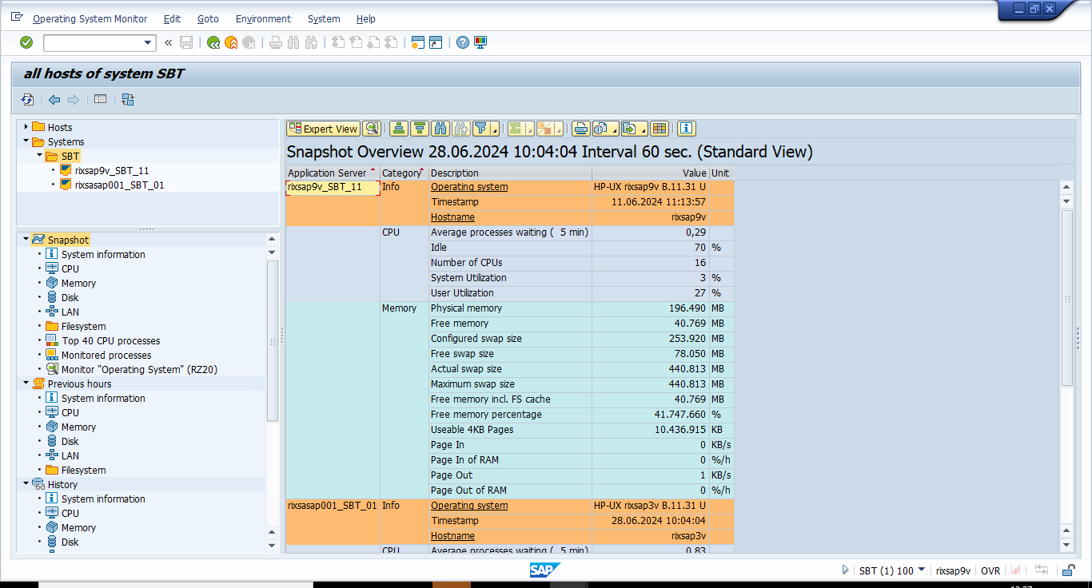
Step10: Enter the T-code ‘/nST07’ and download the report to analyse In WP and Active Users:
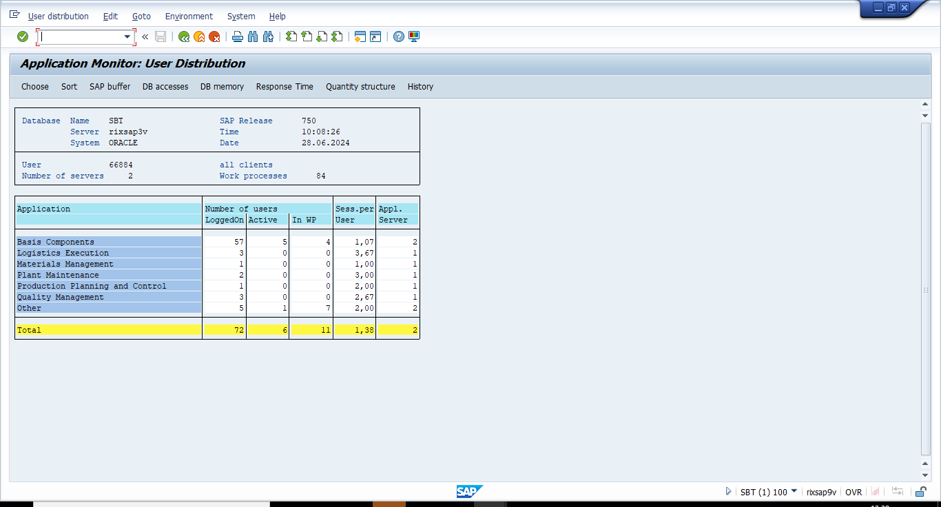

Step 11: Enter the T-code ‘/nST22’ and download the report to get the Dumps count :
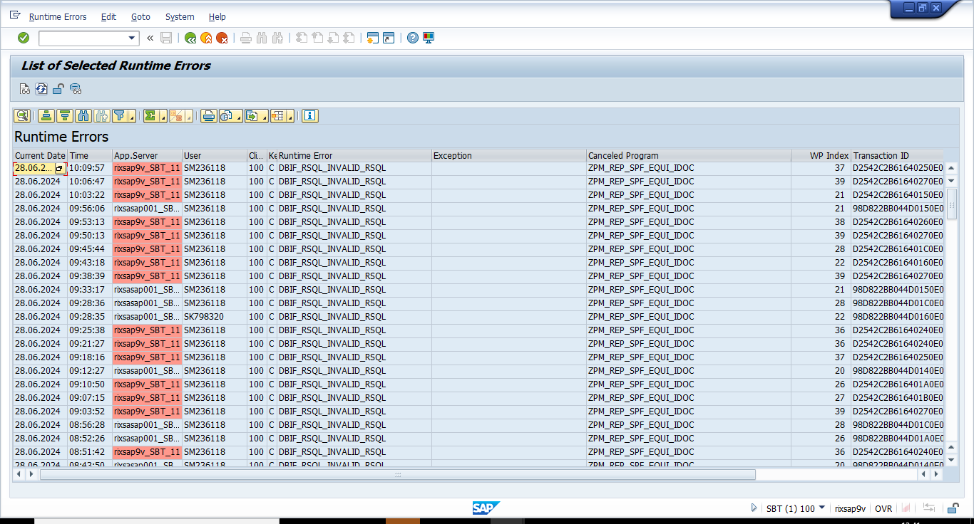

Input Format
NA
Output Format
NA
Output Medium
Print
Screen Summary
NA
Business Logic:
For detailed specification of the development please refer to Appendix – Program Logic
Run Mode
Foreground

System Operation Specification
NA

Data
NA

Security
NA

Revision History
Version | Source |  | Reason For Revision
Version | Deployment | BAU | Reason For Revision
1.0 | June-2024. | NA | This is the first issue of the document and initial version created for AutoSAP_001.

Appendices

Appendix – Selection Screen Definitions
NA

Appendix – Testing Objective
- Every day the hourly SBP monitoring is done by logging into SAP.
- This process involves checking the various transactions DB01, DB02, SE38, SM37, SM51, SM58, SM59, SMLG, ST06, ST07, ST22.
- At the end of monitoring a report is prepared and an email notification is sent to BASIS Team.
Appendix – Screen Layout Definition
NA

Appendix – Program Logic
Element ID | Logic Description
Autosap_SBP Hourly Monitoring | Step 1:  - Log in to the SBP system.  - Enter the T-Code /ndb01 execute and take the screenshot.  Step 2:  - Enter T-code : /nDB02  - Go to Space > Tablespaces > Overview to get the Table Space Names and its respective Used %.  Step 3:  - Enter the transaction /nSE38 and give – Program: ‘/SDF/MON’ and select ‘Variants’ and click on Display.  - Then give the Variant as ‘Test’(any name) and click on Create.  - Then select – ‘For All Selection Screens’ on the pop up then click on ‘continue’  - Click on ‘Schedule New Monitoring’ and ‘Show Analysis’ In respective screens to get the below report:  - Analyse and find the Logins and sessions,Extended memory, heap memory and WPs from the above report.  Step 4:  - Enter the T-code /nSM37 and check if any job is running more than one day  Step 5:  - Enter the transaction /nSM51 and take the screenshot.  Step 6:  - Enter the transaction /nSM58 and check Transaction RFCs for Current Day with Username as ‘*’.  .Step 7:  - Enter the transaction /nSM59 and go to TCP/IP Connections and check if the below Seal Servers are active or not.  Step 8:  - Enter /nSMLG transaction and take the screenshot:  Step 9:  - Enter the /nST06 T-code and click on ‘SBP’ System name and download the report to analyse the CPU%, Free Memory, RAgent and “oracle/SBP/oraarch” Disk CPU.  Step 10:  - Enter the T-code ‘/nST07’ and download the report to analyse In WP and Active Users  Step 11:  - Enter the T-code ‘/nST22’ and download the report to get the Dumps count

Appendix – Output Layout Details
NA

Appendix – Sample Output Formats
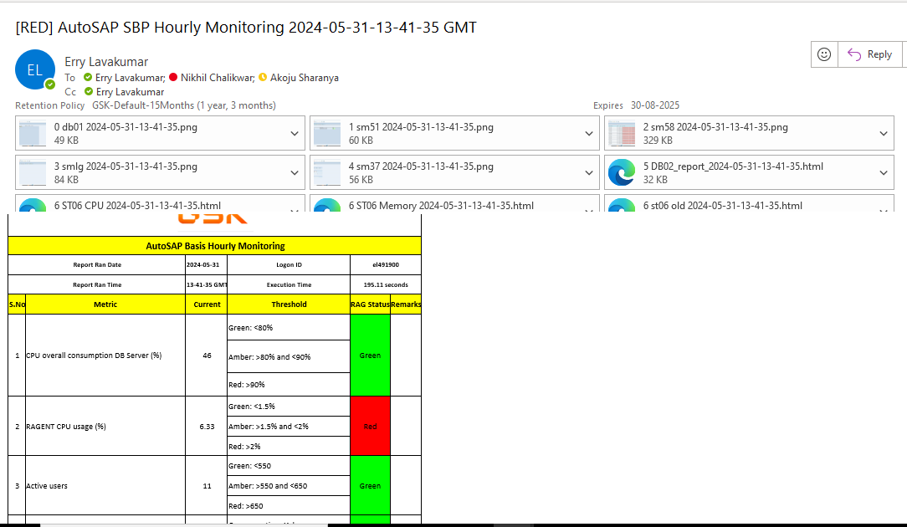

Appendix – Function Module Detail
NA
Appendix – Further Solution-specific sections
NA
Appendix – IDOC Detail
NA
Appendix – Data Dictionary Objects
NA
Appendix – Portal / Java Developments
NA
Appendix – Data
NA

